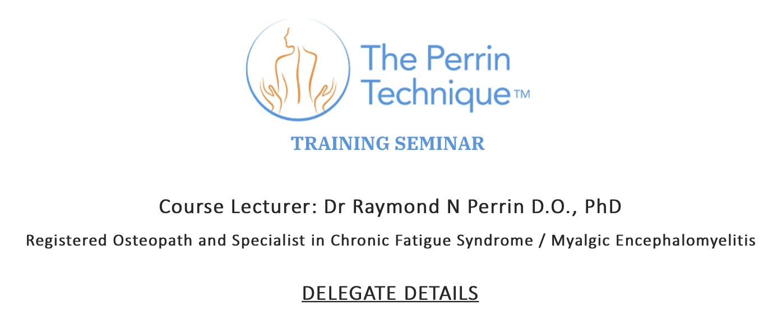

|  |  |
| --- | --- |
| **NAME** |  |
| **QUALIFICATIONS** |  |
| **PRACTICE ADDRESS** |  |
| **PRACTICE PHONE NUMBER(S)** |  |
| **PRACTICE EMAIL** |  |
| **PRACTICE WEBSITE** |  |
| *The following information is for our records only and will not be published* | |
| **HOME / PERSONAL CONTACT DETAILS** **(PHONE AND EMAIL)** |  |